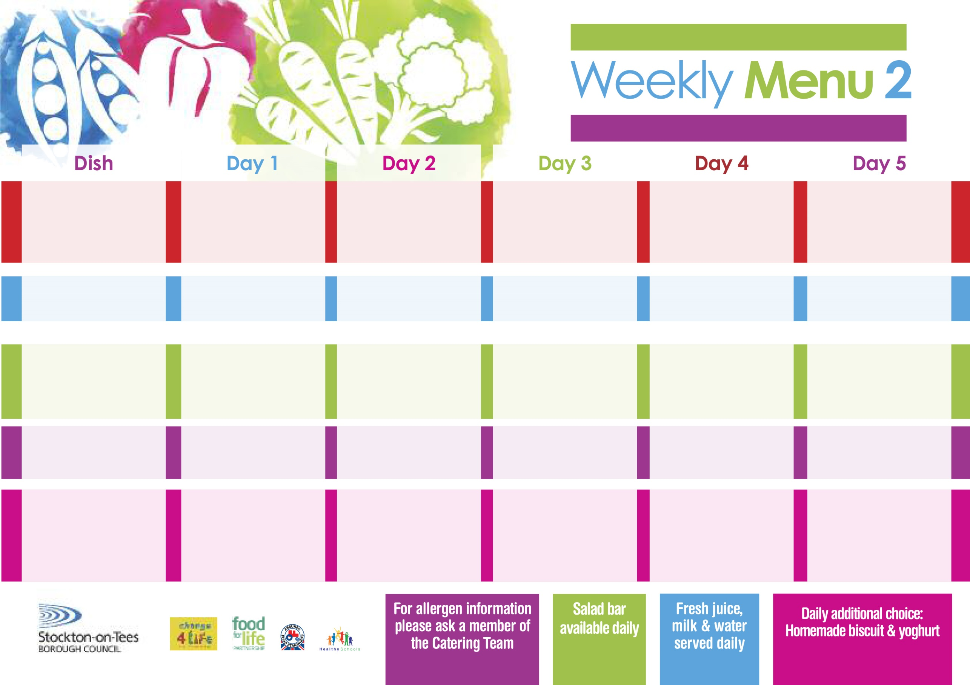

**Mince & Yorkshire Puddings**

**Oven Roasted Potatoes**

**Swede**

**Broccoli**

**Loaded Vegetable Pizza (V)**

**Oven Roasted Potatoes**

**Baked Beans**

**Tuna Sandwich**

**Oven Roasted Potatoes**

**Apple Crumble**

**with Custard Sauce**

**Cold Bar**

**Fresh Fruit Bowl**

**Roast Chicken served with Sage & Onion Stuffing**

**Baby Boiled Potatoes**

**Baton Carrots**

**Cabbage**

**Cheese Quiche (V)**

**Baby Boiled Potatoes**

**Spaghetti Hoops**

**Egg Mayonnaise Wrap (V)**

**Baby Boiled Potatoes**

**Syrup Sponge**

**with Custard Sauce**

**Cold Bar**

**Fresh Fruit Platter**

**10th September, 8th October, 12th November & 10th December, 2018**

**Chicken Curry**

**Rice**

**Mixed Vegetables**

**Cauliflower**

**Vegetable Curry (V)**

**Oven Baked Jacket Potato**

**served with:-**

**Tuna, Cheese (V)**

**or Baked Beans (V)**

**Tuna Wrap**

**Baby Boiled Potatoes**

**Chocolate Crunch**

**with Custard Sauce**

**Cold Bar**

**Fresh Fruit Salad**

**Tempura Battered**

**Fish Goujons**

**Oven Baked Chips**

**Garden Peas**

**Baked Beans**

**Macaroni Cheese (V)**

**Homemade Garlic Bread**

**Garden Peas**

**Cheese Savoury Sandwich (V)**

**Oven Baked Chips**

**Chocolate Chip Sponge**

**with Custard Sauce**

**Cold Bar**

**Melon Boat**

**Corned Beef & Carrot Pie**

**Creamed Potatoes**

**Sweetcorn**

**Garden Peas**

**Cheese & Potato Pie (V)**

**Fish Fillet Fingers**

**Creamed Potatoes**

**Sweetcorn**

**Garden Peas**

**Cheese Sandwich (V)**

**Baked Jacket Potatoes**

**Eve’s Pudding**

**with Custard Sauce**

**Cold Bar**

**Watermelon Slices**

**Wristband School Menu**

**Red Choice**

**Blue Choice**

**Green Choice**

**Cold Selection**

**Desserts**