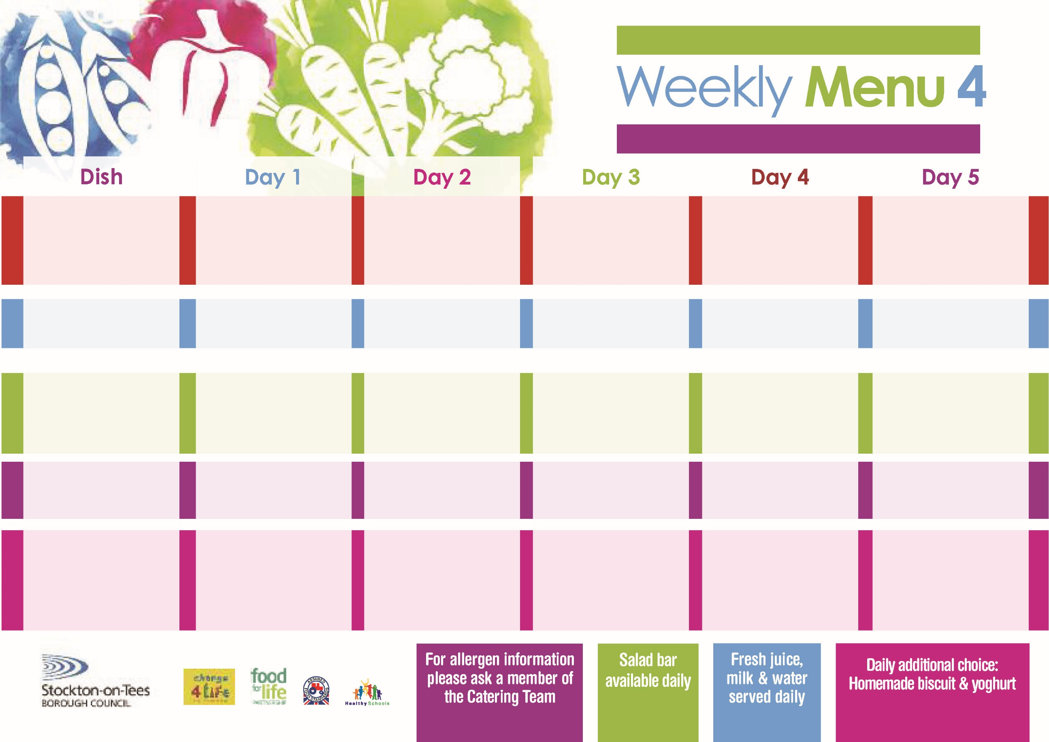

**29th January & 5th March, 2018**

**Chicken Pie**

**Creamed Potatoes**

**Broccoli**

**Mixed Vegetables**

**Oven Baked Jacket Potato**

**served with:-**

**Tuna, Cheese (V)**

**& Baked Beans (V)**

**Ham Sandwich**

**Baked Jacket Potato**

**Creamy Rice Pudding**

**served with Peaches**

**Cold Bar**

**Fresh Fruit Salad**

**Minced Beef &**

**Yorkshire Pudding**

**Creamed Potatoes**

**Diced Carrots**

**Cauliflower**

**Minced Quorn &**

**Yorkshire Pudding (V)**

**Pork & Carrot Meatballs**

**in Tomato Sauce**

**served with Spaghetti**

**Diced Carrots**

**Cauliflower**

**Cheese Savoury Sandwich**

**Baked Jacket Potato**

**Vanilla Sponge**

**with Custard Sauce**

**Cold Bar**

**Melon Boat**

**Mediterranean Beef &**

**Pasta Twirls**

**Homemade Garlic Bread**

**Diced Carrots**

**Sweetcorn**

**Mediterranean Quorn & Pasta Twirls (V)**

**Sausage Rolls**

**Baked Potato Wedges**

**Diced Carrots**

**Sweetcorn**

**Cheese Sandwich**

**Baked Jacket Potato**

**Jam Shortcake**

**with Custard Sauce**

**Cold Bar**

**Watermelon Slices**

**Turkey Burger Bun**

**Oven Roasted Potatoes**

**Baked Beans**

**Garden Peas**

**Quorn Burger Bun (V)**

**Cheese Omelette (V)**

**Oven Roasted Potatoes**

**Baked Beans**

**Garden Peas**

**Tuna Wrap**

**Baked Jacket Potato**

**Chocolate Lime Cake**

**with Custard Sauce**

**Cold Bar**

**Fresh Fruit Bowl**

**Salmon Fillet Fingers**

**Oven Baked Chips**

**Garden Peas**

**Spaghetti Hoops**

**Margarita Pizza (V)**

**Oven Baked Chips**

**Garden Peas**

**Spaghetti Hoops**

**Egg Wrap**

**Baked Jacket Potato**

**Sticky Toffee Pudding**

**with Custard Sauce**

**Cold Bar**

**Fresh Fruit Kebab**

**Red Choice**

**Blue Choice**

**Green Choice**

**Cold Selection**

**Desserts**

**Wristband School Menu**