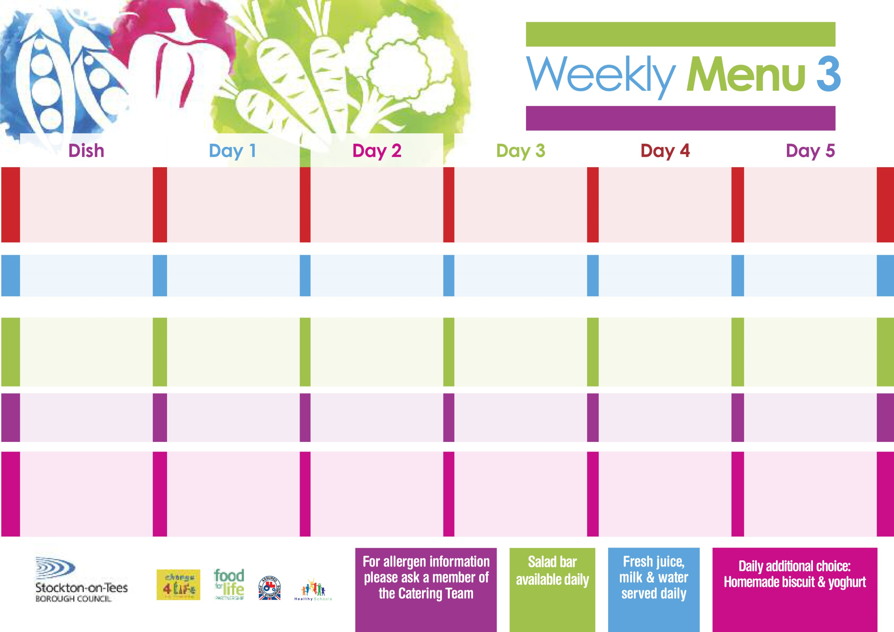

**Minced Beef &**

**Yorkshire Pudding**

**Creamed Potatoes**

**Broccoli**

**Mixed Vegetables**

**Minced Quorn**

**& Yorkshire Pudding (V)**

**Baked Jacket Potato filled with:-**

**Tuna, Cheese (V) or**

**Baked Beans (V)**

**Egg Mayonnaise Sandwich**

**Baked Jacket Potato**

**Syrup Roly Poly**

**with Custard Sauce**

**Cold Bar**

**Fresh Fruit Bowl**

**Sweet & Sour Pork**

**Hot Rice**

**Diced Carrots**

**Green Beans**

**Sweet & Sour Quorn (V)**

**Fish Fillet Fingers**

**Oven Roast Potatoes**

**Baked Beans**

**Cheese Savoury Sandwich**

**Baked Jacket Potato**

**Lemon Sponge**

**with Custard Sauce**

**Cold Bar**

**Melon Boats**

**Roast Gammon**

**with Pineapple**

**Baby Boiled Potatoes**

**Garden Peas**

**Baton Carrots**

**Cheese & Vegetable**

**Bakes (V)**

**Tuna Melts**

**Baby Boiled Potatoes**

**Garden Peas**

**Baton Carrots**

**Cheese & Tomato Sandwich**

**Baked Jacket Potato**

**Chocolate Crunch**

**with Peppermint Sauce**

**Cold Bar**

**Fresh Fruit Salad**

**Tempura Battered**

**Fish Fillet**

**Oven Baked Chips**

**Sweetcorn**

**Baked Beans**

**Oven Baked Cheese Rolls (V)**

**Oven Baked Chips**

**Sweetcorn**

**Baked Beans**

**Tuna & Cucumber Wrap**

**Baked Jacket Potato**

**Festival Shortcake**

**with Custard Sauce**

**Cold Bar**

**Fresh Fruit Platter**

**Spaghetti Bolognaise**

**Homemade Garlic Bread**

**Garden Peas**

**Sweetcorn**

**Margarita Pizza (V)**

**Baked Potato Wedges**

**Garden Peas**

**Sweetcorn**

**Tuna Wrap**

**Baked Jacket Potato**

**Apple & Rhubarb Crumble**

**with Custard Sauce**

**Cold Bar**

**Fresh Fruit Kebab**

**18th September, 16th October, 20th November & 18th December, 2017**

**Red Choice**

**Blue Choice**

**Green Choice**

**Cold Selection**

**Desserts**

**Wristband School Menu**