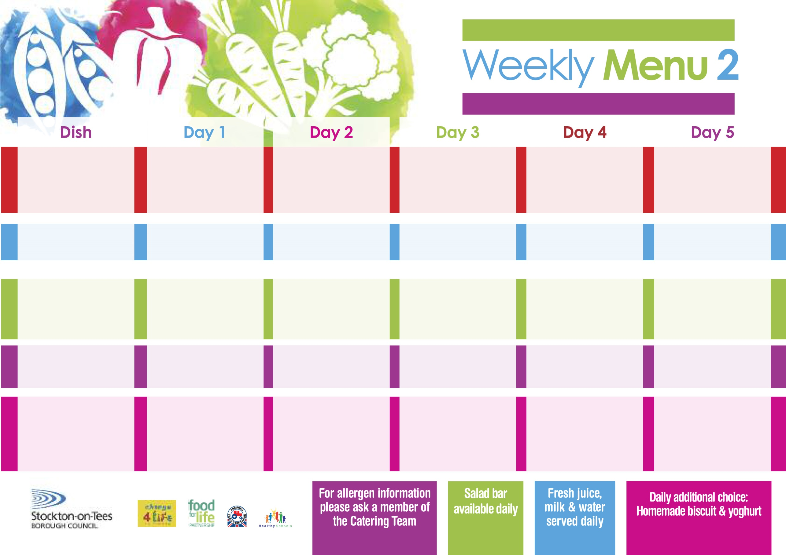

**Beef Curry**

**served with Rice**

**Sweetcorn**

**Baton Carrots**

**Vegetable Curry (V)**

**Fish Cake in Natural Crumb**

**Baked Jacket Potato**

**Sweetcorn**

**Baton Carrots**

**Cheese Sandwich**

**Baked Jacket Potato**

**Chocolate Chip Sponge**

**with Custard Sauce**

**Cold Bar**

**Fresh Fruit Bowl**

**11th September, 9th October, 13th November & 11th December, 2017**

**Corned Beef Pie**

**Creamed Potatoes**

**Creamed Carrot & Swede**

**Baked Quorn Sausages (V)**

**Baked Sausages**

**Oven Roasted Potatoes**

**Sweetcorn**

**Baked Beans**

**Cheese & Tomato Wrap**

**Baked Jacket Potato**

**Marble Sponge**

**with Custard Sauce**

**Cold Bar**

**Fresh Fruit Salad**

**Tempura Battered**

**Fish Goujons**

**Oven Baked Chips**

**Garden Peas**

**Baked Beans**

**Oven Baked Jacket Potato**

**served with:-**

**Tuna, Cheese (V)**

**Or Baked Beans (V)**

**Tuna Sandwich**

**Baked Jacket Potato**

**Mandarin Orange Sponge**

**with Custard Sauce**

**Cold Bar**

**Melon Boat**

**Breaded Chicken Breast**

**Baked Potato Wedges**

**Baked Beans**

**Garden Peas**

**Pizza Whirl (V)**

**Baked Potato Wedges**

**Baked Beans**

**Garden Peas**

**Tuna & Cucumber Sandwich**

**Baked Jacket Potato**

**Bakewell Tart**

**with Custard Sauce**

**Cold Bar**

**Watermelon Slices**

**Mince & Dumplings**

**Creamed Potatoes**

**Mixed Vegetables**

**Cauliflower**

**Macaroni Cheese (V)**

**Homemade Garlic Bread**

**Mixed Vegetables**

**Cauliflower**

**Egg Mayonnaise Wrap**

**Baked Jacket Potato**

**Apple Crumble**

**with Custard Sauce**

**Cold Bar**

**Fresh Fruit Platter**

**Wristband School Menu**

**Red Choice**

**Blue Choice**

**Green Choice**

**Cold Selection**

**Desserts**